Supplemental Material
Characterization and Stability Evaluation of Nanoencapsulated Epoxy Lignans

Yusnita Rifai ^{1*}, Radhia Riski¹ , Gemini Alam¹, Magdalena Litaay² and Latifah Rahman¹
¹ Pharmaceutical Chemistry Laboratory, Faculty of Pharmacy Hasanuddin University, Makassar 90245, Indonesia
² Biology Departement, Faculty of Mathematics and Life Sciences Hasanuddin University, Makassar 90245, Indonesia

Structure of 3',6-dimethoxy-3'',4''-(methylenedioxy)-2,5-epoxylignan-4'-ol (DMEO)
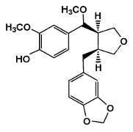

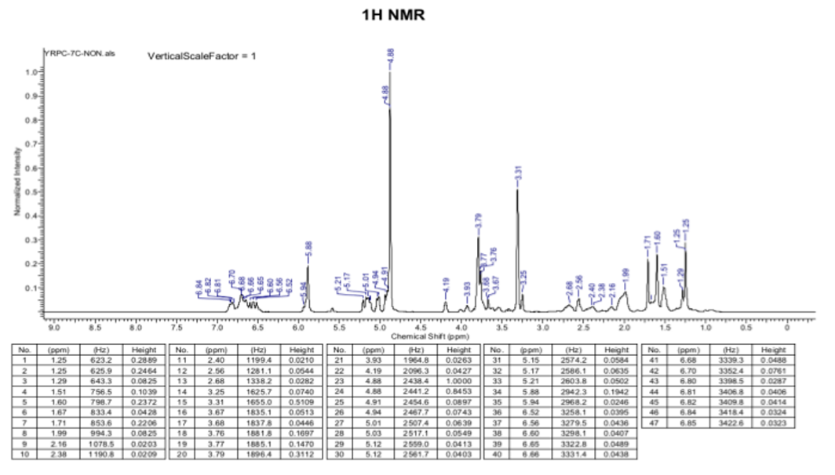
¹H and ¹³C NMR of DMEO

