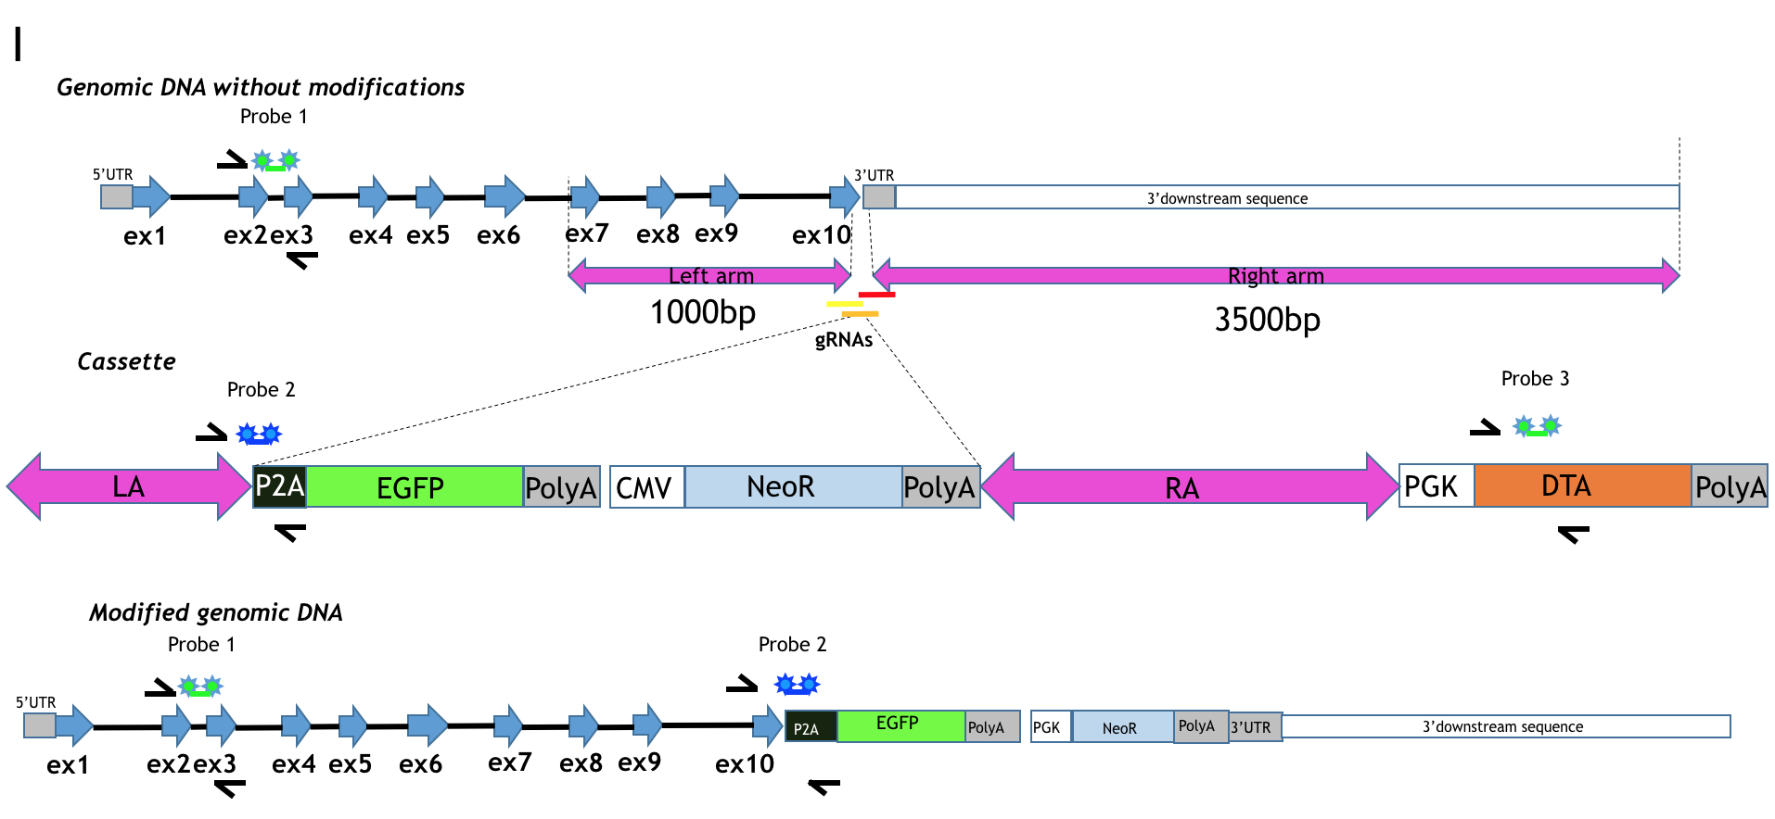
CRISPR/Cas Gene Editing Technology. G3 (Bethesda). 2016 Jun 1;6(6):1787-92.
