Supplementary File 1.

Amplification picture
Amplification result of LAB DS15 is number 2
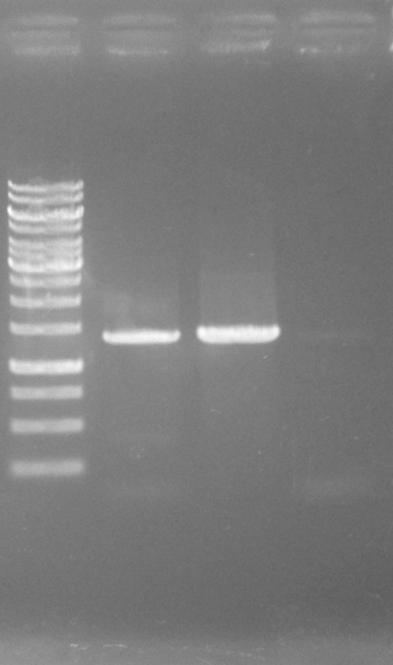
1kb DNA ladder 1 2 NTC
1400bp
1000
1500

