Supplementary material for Balcom et al. 2016

Figures S1-S22

Caption for Figures S1-S2:

Phylograms depicting the lowest common ancestor taxonomic profile for Human Microbiome Project (HMP) control sample 902 and CosmidID’s constructed freshwater sample from the Delaware River generated in MEGAN 5.7.10 software. The number of reads associated with each taxonomic classification is shown. The minimum-support percent threshold in MEGAN analyses was set to 1.0 %.

Caption for Figures S3-S14:

Phylograms depicting the lowest common ancestor taxonomic profile for each of the WWTP samples generated in MEGAN 5.7.10 software. The notation used to indicate aqueous and immersed biofilm samples is _W and _B, respectively. The number of reads (normalized) associated with each taxonomic classification is shown. The minimum-support percent threshold in MEGAN analyses was set to 1.0 %.

Caption for Figures S15-S22:

Phylograms depicting the lowest common ancestor taxonomic profile for each of the sole pharmaceutical compound carbon source enrichment culture samples generated in MEGAN 5.7.10 software. The notation used to indicate cultures grown on carbamazepine, trimethoprim, and sulfamethoxazole carbon sources is C, T, and S, respectively, and trailing numbers indicate replicate number. The number of reads (normalized) associated with each taxonomic classification is listed to right of each terminal taxon. The minimum-support percent threshold in MEGAN analyses was set to 1.0 %.

Figure S1

HMP 902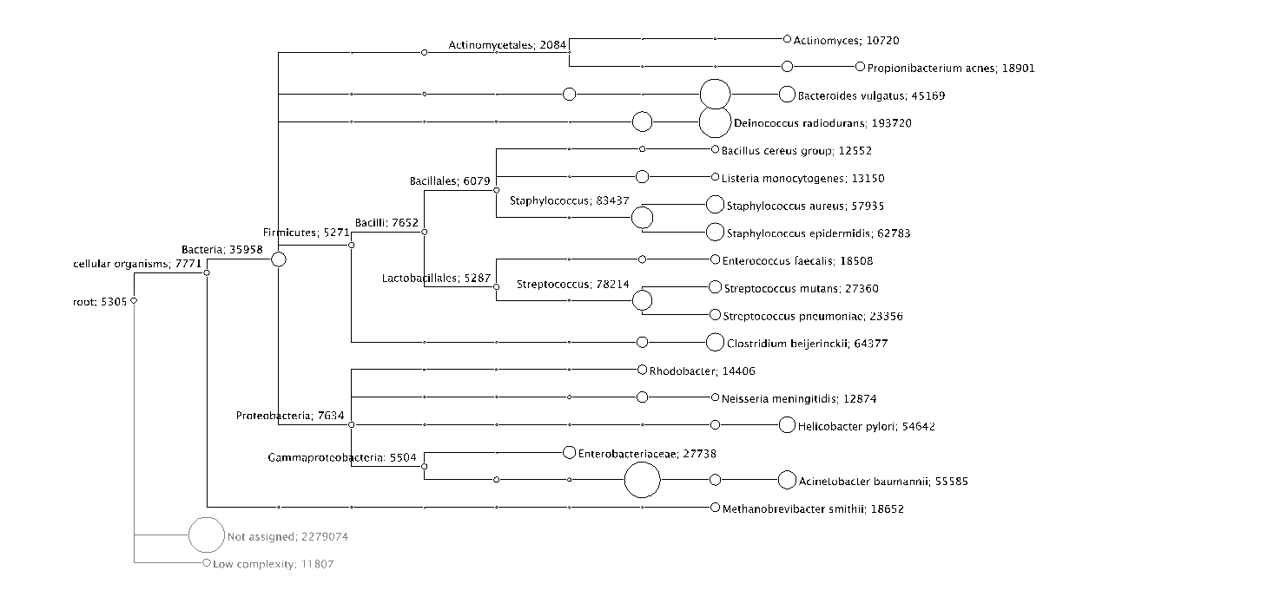

Figure S2

Delaware River

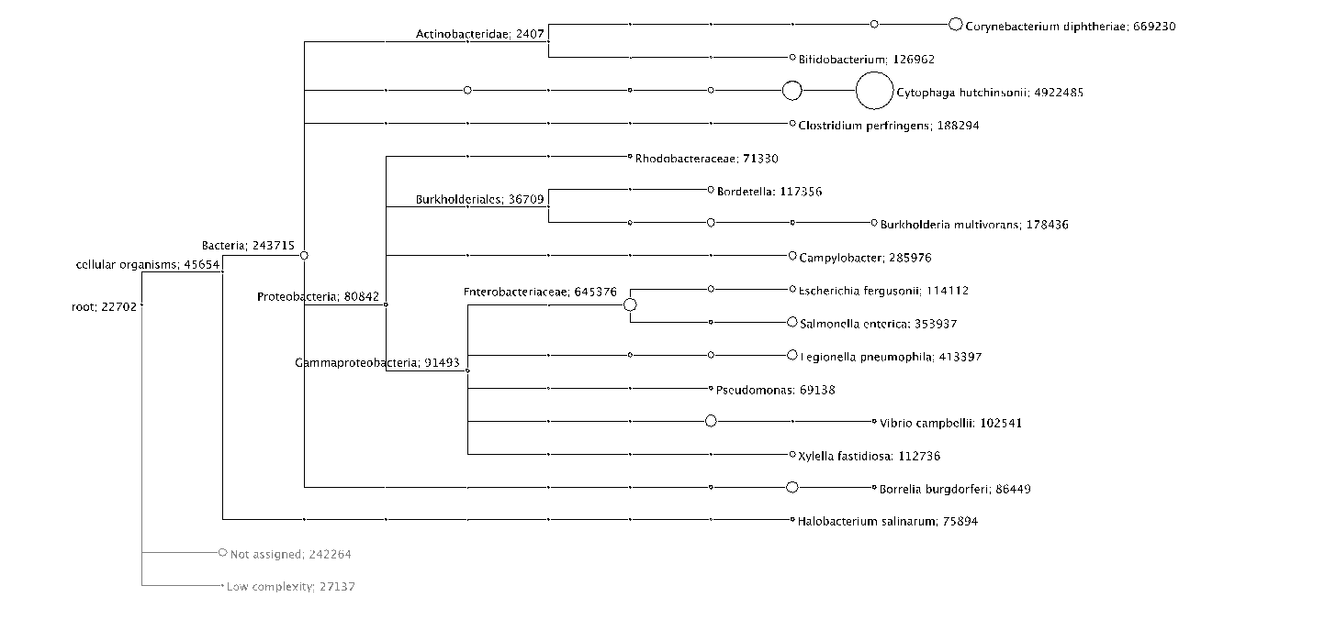

Figure S3

ANOX_B

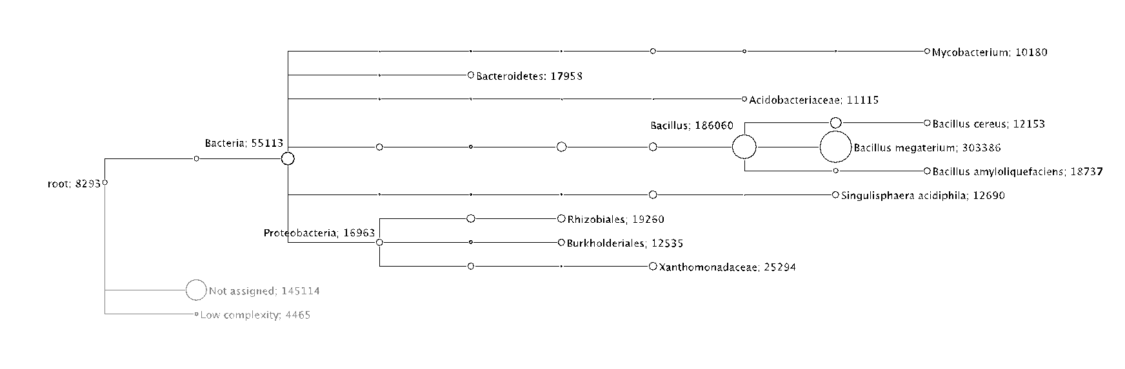

Figure S4

ANOX_W

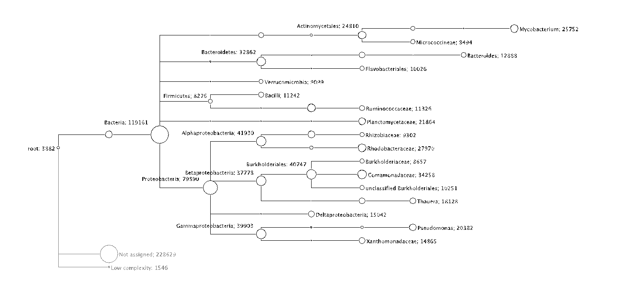

Figure S5

CLO_B

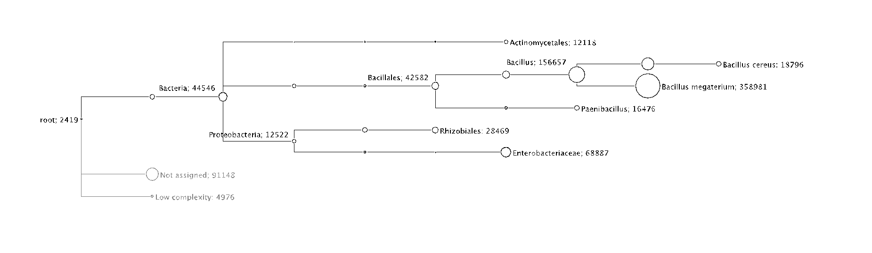

Figure S6

CLO_W

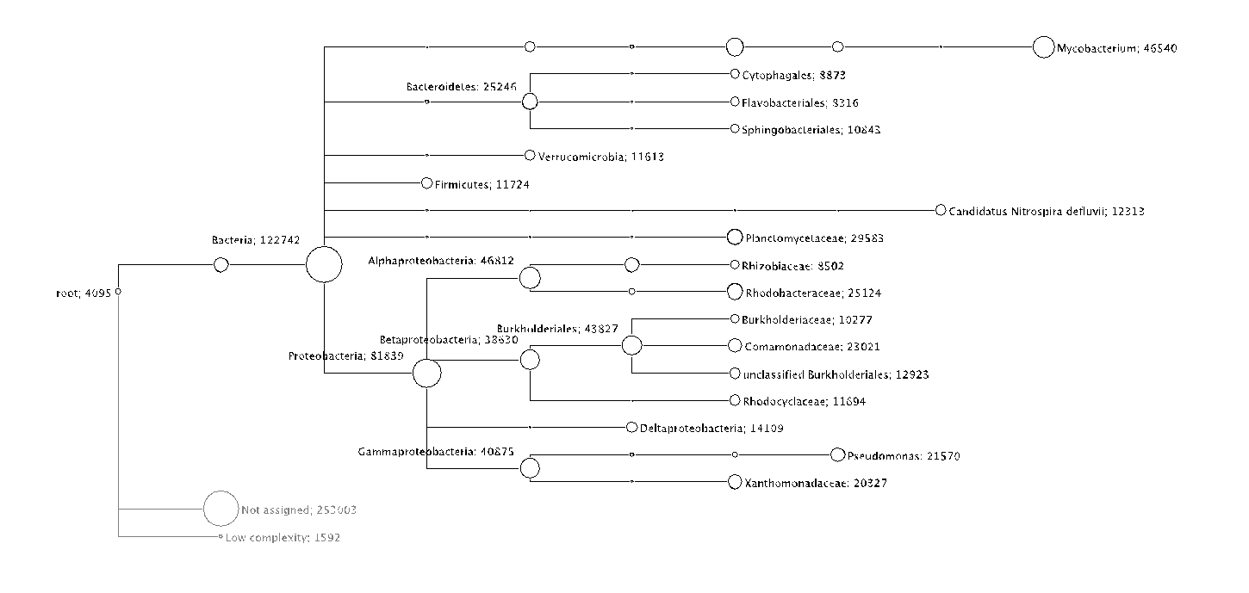

Figure S7

HR1_B

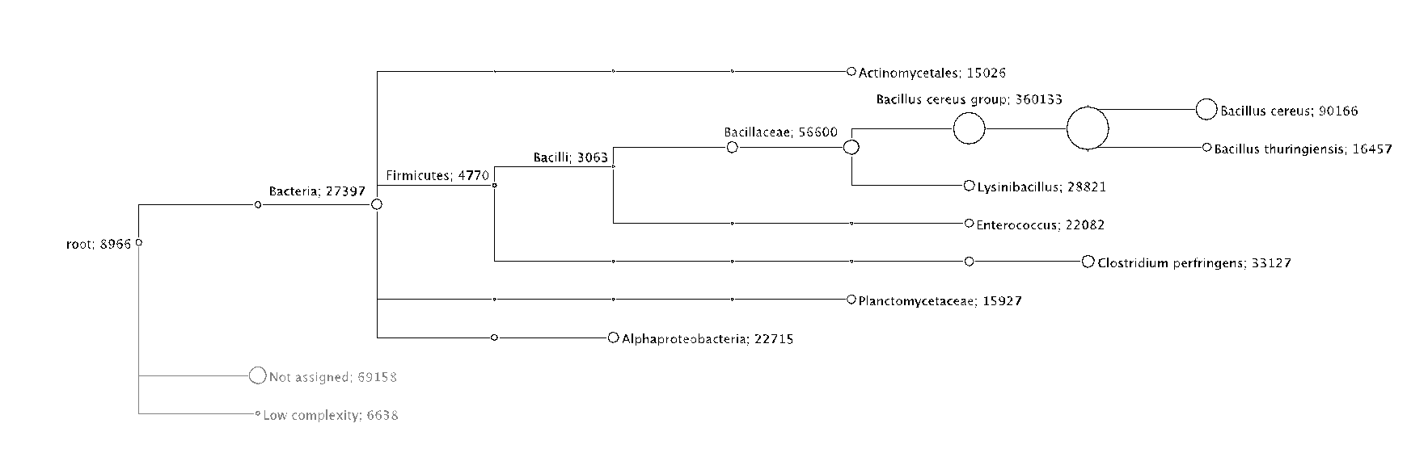

Figure S8

HR1_W

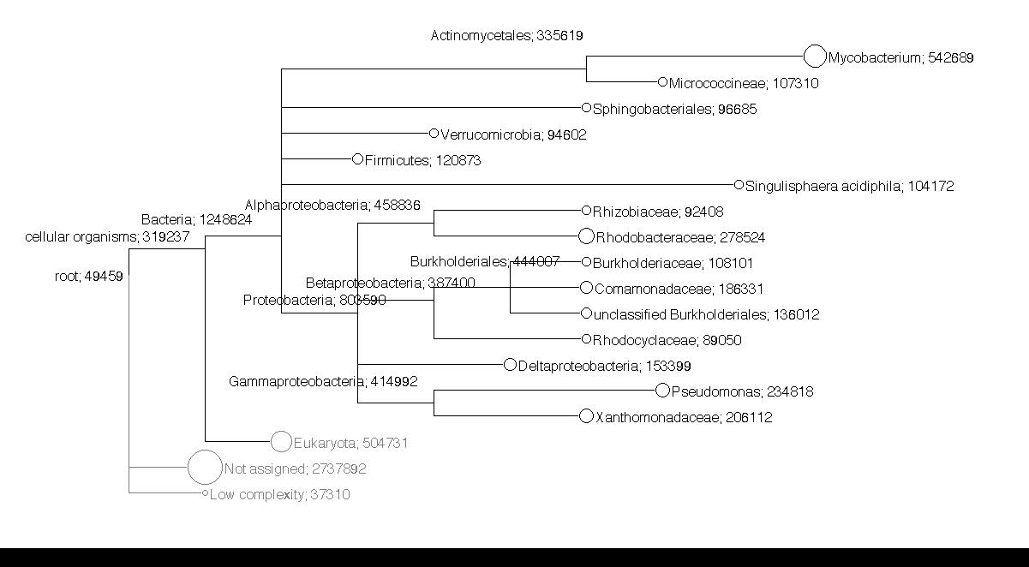

Figure S9

HR2_B

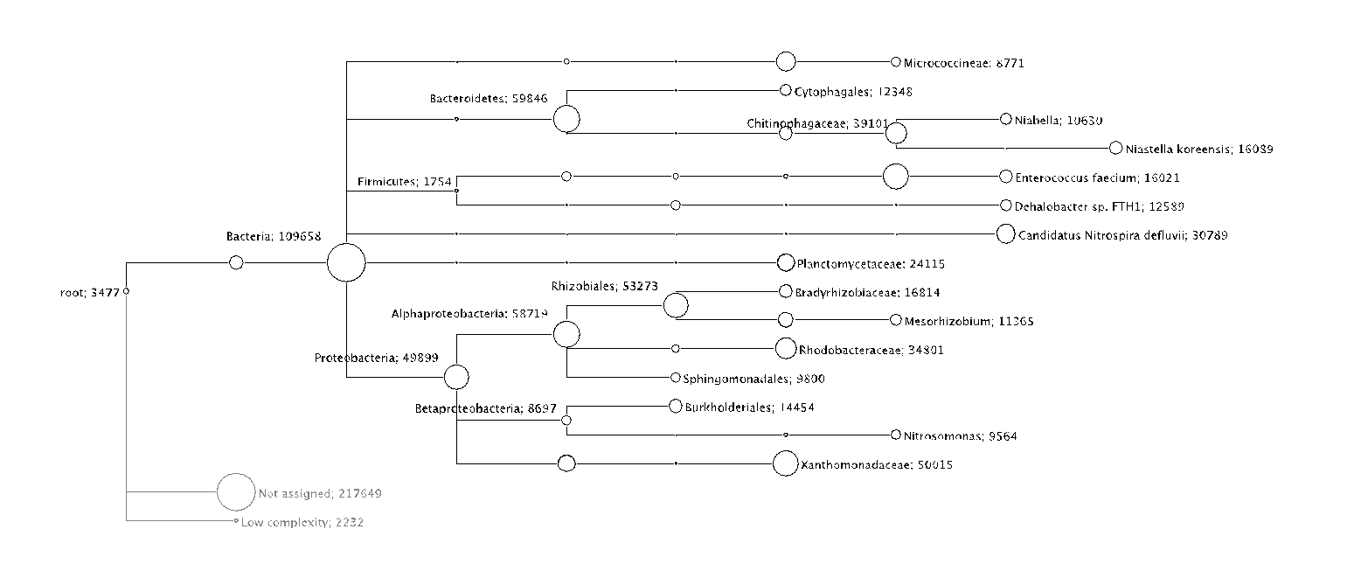

Figure S10

HR2_W

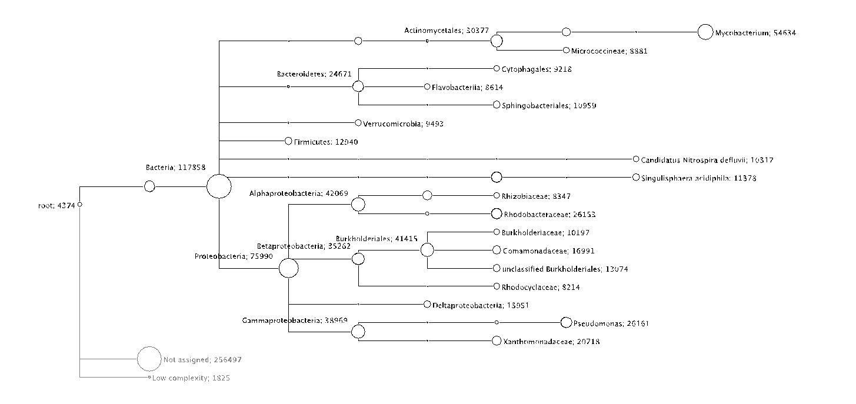

Figure S11

HR3_B

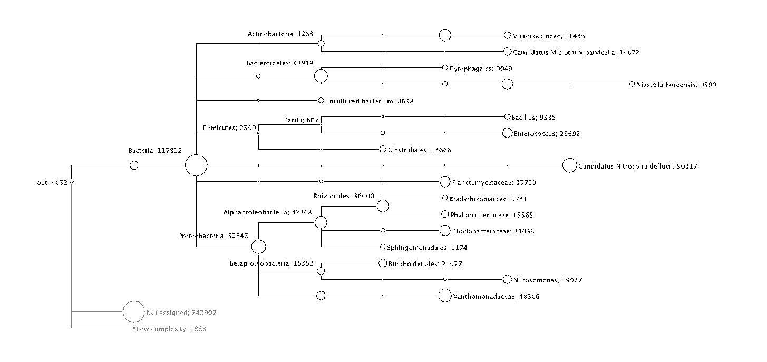

Figure S12

HR3_W

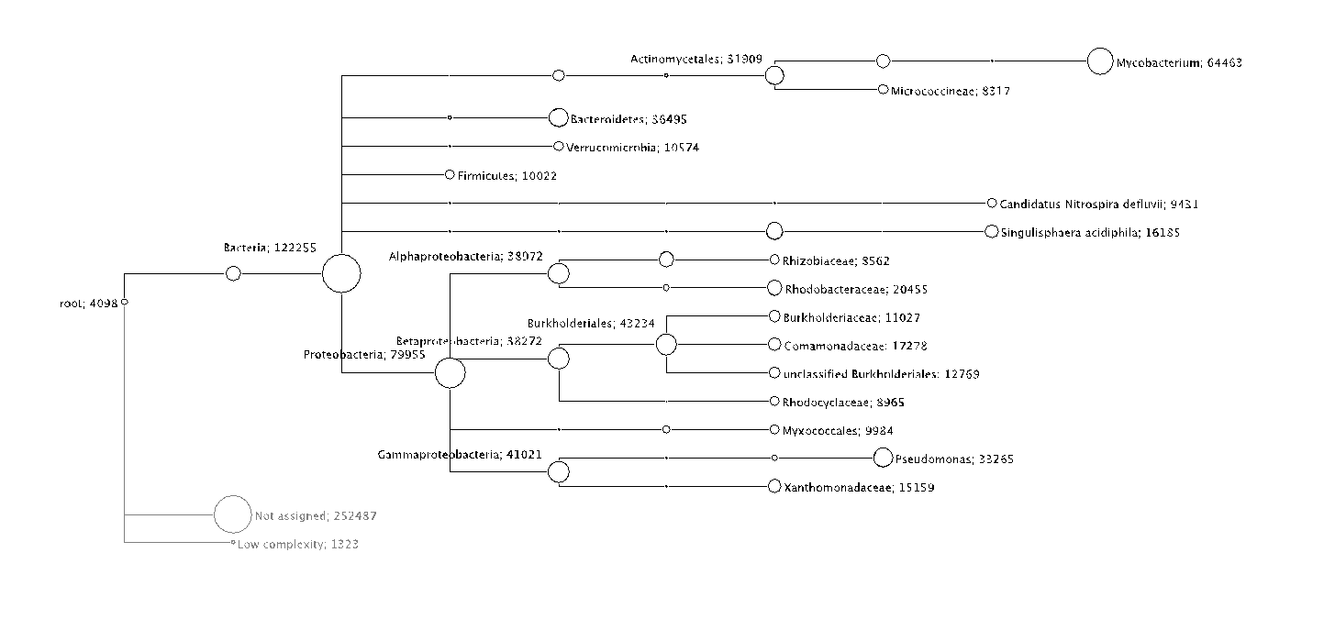

Figure S13

SAND_B

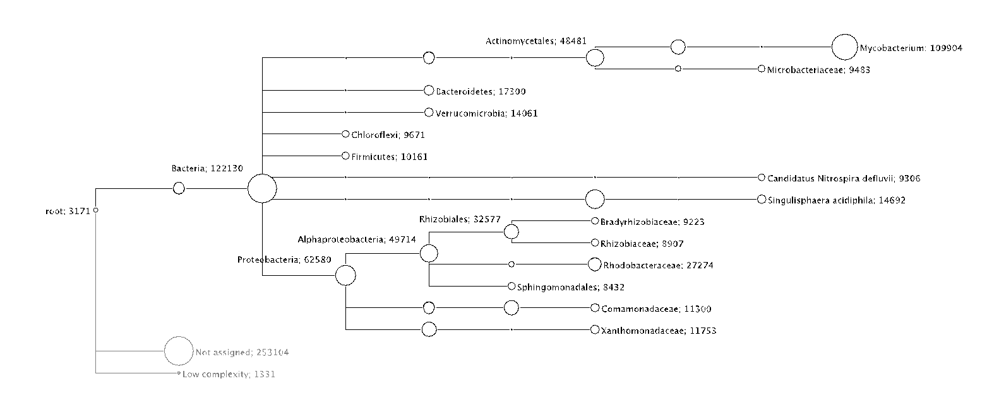

Figure S14

SAND_W

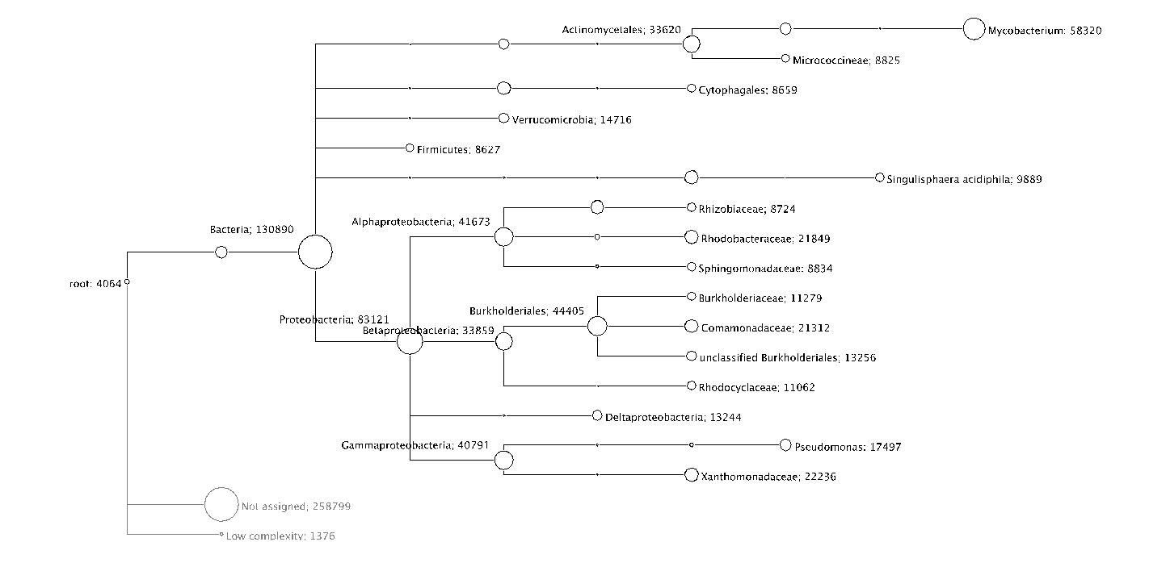

Figure S15

C3A

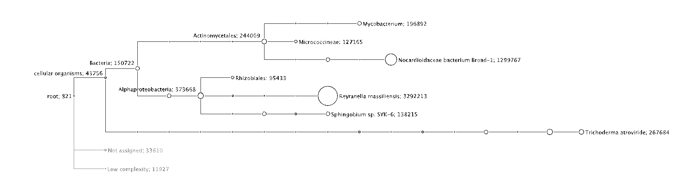

Figure S16

C3B

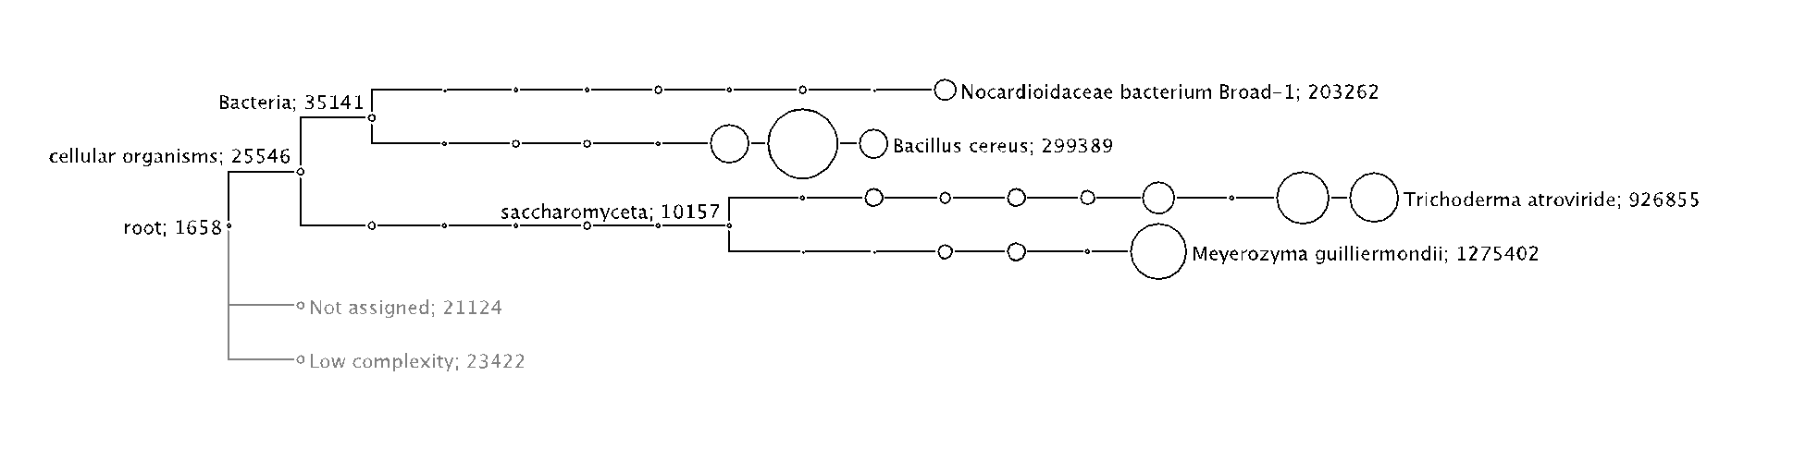

Figure S17

C3D

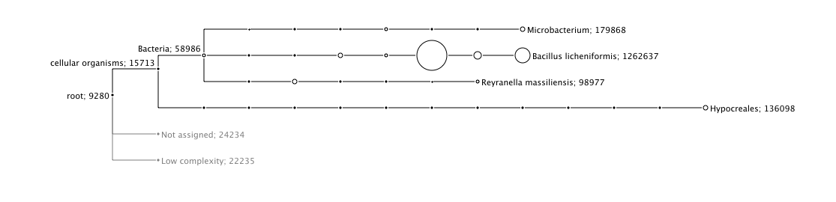

Figure S18

S3B

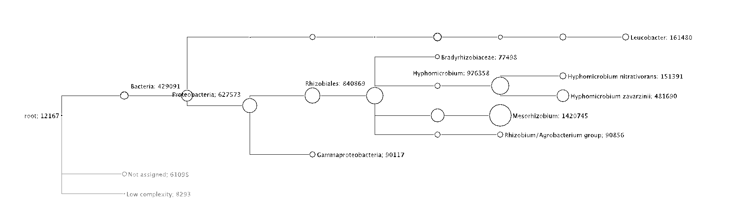

Figure S19

S3D

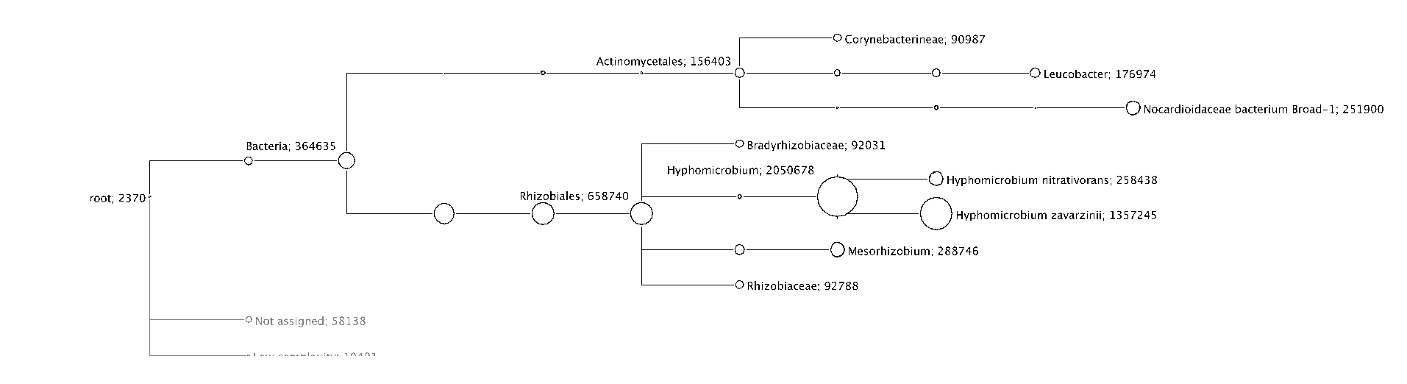

Figure S20

T3B

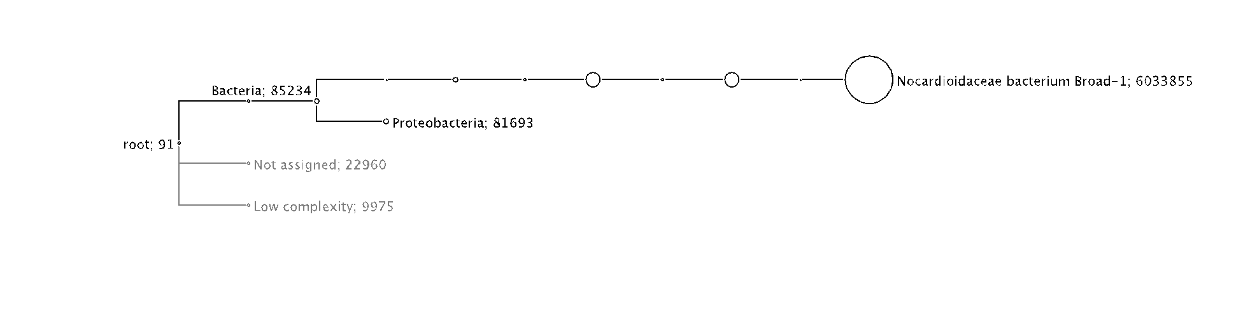

Figure S21

T3C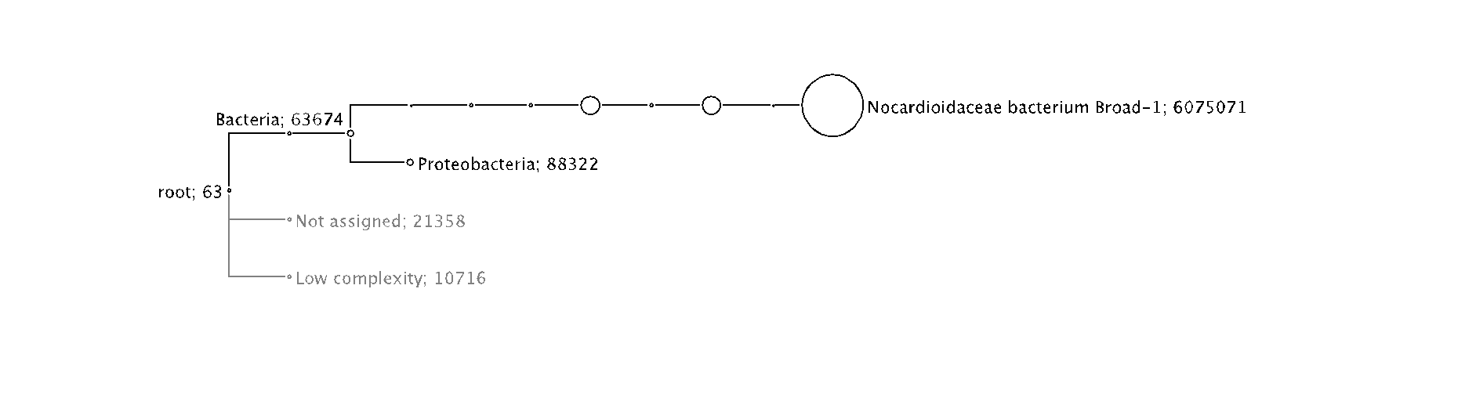

Figure S22

T3D

