**Supplementary File 2**

**Field and drip layout of experiment & drip components**

**Treatment information**

Design : Split - Split - Plot Design

Replication : Three

Plot size : 2.4 x 7.0 m

**Treatments :**

**Main plot: Water Sources**

S1 - Solar Pump

S2 - Well Submersible Pump

**Sub Plot: Genotypes**

V1 - TNRH 180 (Pipe-line hybrid culture)

V2 - JKRH 3333 (Hybrid)

V3 - ADT (R) 45 (Variety)

**Sub-Sub-Plot: Lateral Design**

T1 - Sub-surface drip with lateral distance of 0.8 m buried at a depth of 5-10 cm

T2 - Sub-surface drip with lateral distance of 1.2 m buried at a depth of 5-10 cm

T3 - Sub-surface drip with lateral distance of 0.8 m buried at a depth of 15-20 cm

T4 - Sub-surface drip with lateral distance of 1.2 m buried at a depth of 15-20 cm

T5 - Conventional surface irrigation (IW / CPE = 1.25)

**Field and drip layout of experiment**

Source of irrigation: S 1, solar powered; S 2, well operated. Drip treatments: T 1, 0.8m LD+5-10cm; T 2, 0.8m LD+5-10cm; T 3, 1.2m LD+5–10cm; T 4, 1.2m LD+15–20cm; T 5, conventional aerobic rice. Genotypes: V 1, TNRH 180; V 2, JKRH 3333; V 3, ADT(R)45.

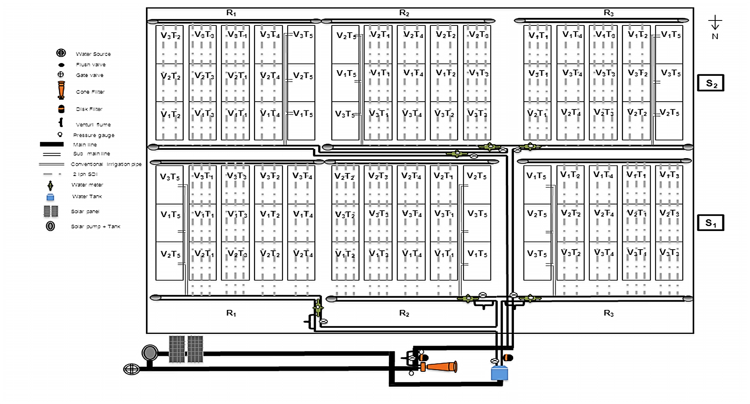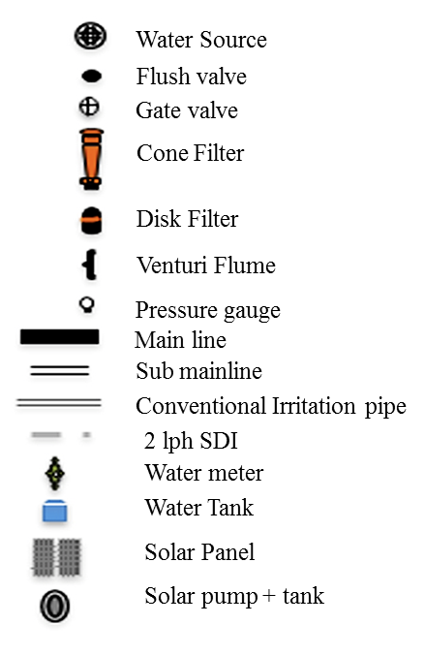

**Components of drip irrigation system used in the experiment**

